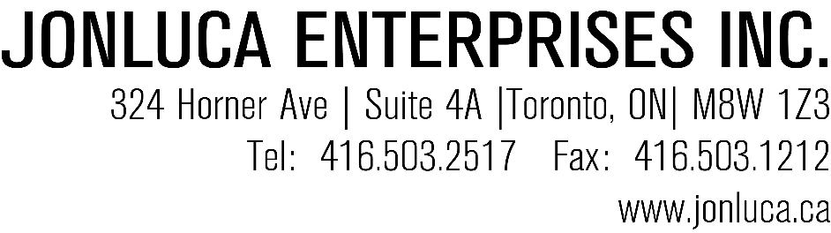
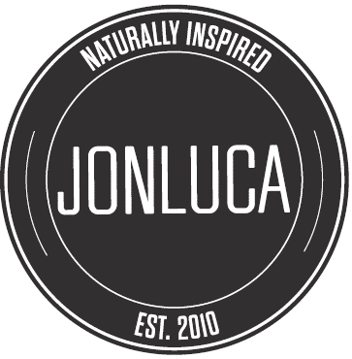
PRODUCT APPLICATION FORM

Please do not load any items to Jonluca on GS1 unless explicit consent has been giving that Jonluca will be moving forward with the listing.

Before filling in the form please ensure you meet these basic requirement:

- A minimum of 25 active accounts currently purchasing your products(s)
- You have practical and feasible logistics, either pick up or delivery, ie. Proximity, lift gates, loading docks
- Your cost has distribution margin and promotional cost built in

STEP 1:
SUPPLIER INFORMATION
Company Name:  Brand Name: | Full Business Address:
Main Contact & Title: | Website:
Contact Phone Number:  Email: | Number of years in business:

PRODUCT INFORMATION
*If product line are same cost please list out names and only fill in 1 form*
Product Name: | UPC:
Unit Size: | Are the UPC (s) GS1 Certified?
Case Size: | Case Dimensions (in):  Length:  Width:  Height:
Pallet Dimension (in):  Length:  Width:  Height: | Cases Per Layer:  Layers Per Pallet:  Total Cases Per Pallet:
Location of Product Production: | Guaranteed Shelf Life:
Minimum Order: | Lead Time:

PRODUCT FEATURES
*PLEASE ONLY MARK IF YOU HAVE CERTIFICATION*
Organic |  | Kosher | Vegan |  | Gluten-Free | Non-Gmo | Halal | Canadian | Dairy Free |  | Nut Free | Trans-fat Free |  | Chill | Frozen | Dry
 | Packaging Type |  |  | Does the Product have Retail Barcode? |  |  | Does the Product have Bilingual Label? |  |  | Does the Product have Nutritional Label? |  |  | Does the Product have Ingredient Label?

COST INFORMATION
Cost Delivered to Jonluca  Per Unit:  Per Case: | Shipping done by (if applicable):
Cost Picked up by Jonluca  Per Unit:  Per Case:  Location: | SRP Unit:  SRP Case:  Current Cost Independents:  Current Cost Chain Listings:

MARKET INFORMATION
Do you have a Current Broker? If so, Who?
Do you have a Current Distributors (s)? If so, Who?

Are you looking for Jonluca to take over distribution?
How did you hear of Jonluca?
Jonluca requires 20 – 30 active listings. Where are you listed?
What are you existing sales in Ontario? If not in Ontario, where and what are you current overall sales?

STEP 2:

Please Attach sell sheets pdf or corporate presentation, including photos of the product packaging, Ingredients table and Nutritional fact table

STEP 3:

Send live samples (no more than 3 units of each sku) to:
*Please don’t send packages with dry ice*

Attention: NEW PRODUCT REVIEW COMMITTEE
Jonluca Enterprises Inc.
324 Horner Ave, Unit 4
Toronto, ON
M8W 1Z3

